Unit 5: Functions
Lesson 6: Graphing a story of function
Objectives:
- I can graph a piecewise function to represent a story
- I can write functions to represent different parts of a piecewise function.
- I can write an absolute value function as a piecewise function.

Agenda:
Applications
Quick Review

Vocabulary:
Piecewise function, step function, story of a function

Focus Questions:
- How do we write a piecewise function to represent a story?
- How can we write an absolute value function as a piecewise function?

Web Support:
- https://www.youtube.com/watch?v=IHf0NYr90VE
- https://www.youtube.com/watch?v=f2F1ZUlE4IA

Web Practice:
- http://www.shmoop.com/linear-equations/piecewise-functions-exercises.html
- https://www.khanacademy.org/math/algebra-home/alg-functions/alg-graphing-nonlinear-piecewise-functions/e/graphing-piecewise-functions

Homework: Finish your 5-6 work

https://www.youtube.com/watch?v=IHf0NYr90VE

Do now:
- Let f be a function such that f(x) = 3x − 4 is defined on the domain 1 ≤ x ≤ 6.
- The range of this function is
- 1 ≤ f(x) ≤ 6 3. −∞ ≤ f(x) ≤ 26
- 26 ≤ f(x) ≤ 1 4. -1 ≤ f(x) ≤ 14

- Calculate the average rate of change over the specific interval from part a.

2)Sam is babysitting during weekends. She charges 20 dollars initial fees and 5 dollars for every hour she babysits. Using the function M(h) = 5h + 20 will determine how much M-Money Sam makes for working h-hours.
  - Calculate and Interpret M(30)

  - Sam is babysitting to buy the latest IPhone that she likes that costs $ 780. Determine how many hours Sam would need to work in order to buy the Phone.

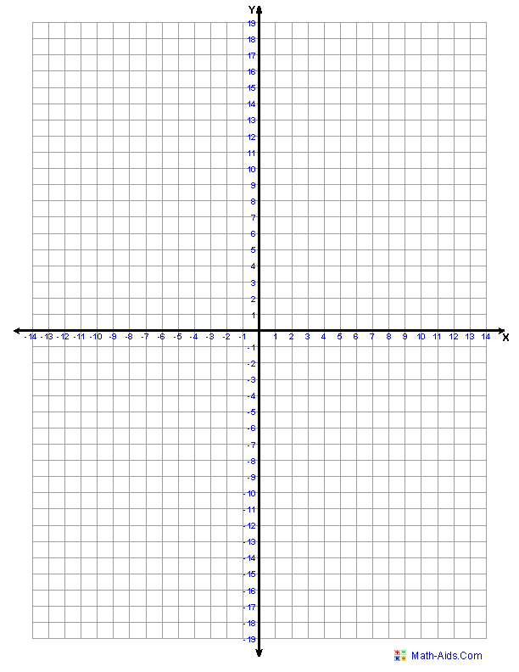
3)Graph and evaluate the following piece wise function
$f\left(x\right)=\left\{\begin{aligned}-2 x<-2 \\ -x+1 -2≤x≤ 0 \\ x^{2}+1 0<x\end{aligned}\right.$

Evaluate the following based on the last piecewise function:
f(-4) b. f(-1) c. f(2) -f(-1)
Working backwards: Writing functions from graphs:
4) Look at the following piecewise function and write an appropriate function that defines it:
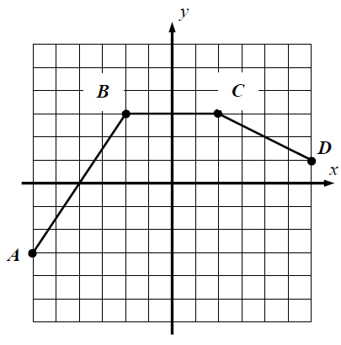

$f\left(x\right)=\left\{\begin{aligned} \\ \\ \end{aligned}\right.$

- Identify the domain and range.

- The y-intercept
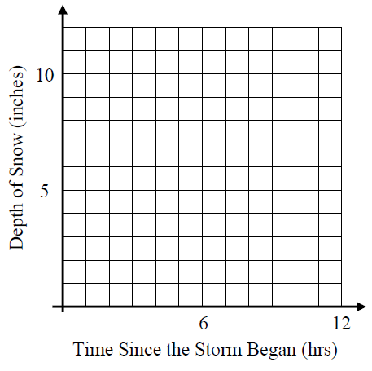
5) A substantial snowstorm is hitting the Northeast region and is predicted to snow at a rate of one-half inch per hour for the first four hours of the storm. The storm is supposed to pause for two hours and then resume at a rate of two inches per hour for the next five hours. The depth, D(t), of the storm is the total number of inches of snow that has fallen at a given time.

- Graph the snow depth as a function of time since the storm began for the length of the storm.

(b) Determine a piecewise linear function for D(t) as a function of the number of hours, t, since the storm began.

$$D(t)=\left\{\begin{aligned} \\ \\ \end{aligned}\right.$$

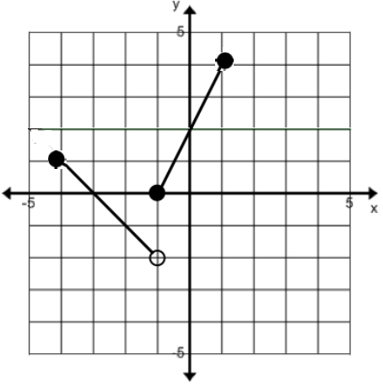
5) Write a piece wise function for the following graph:

$$f\left(x\right)=\left\{\begin{aligned} \\ \end{aligned}\right.$$

6)The temperature is falling outside at a steady rate of 4 degrees Fahrenheit every hour. If the temperature starts at 68 Fahrenheit do the following. Fill out the table below for the outside temperature during the time it is cooling down.
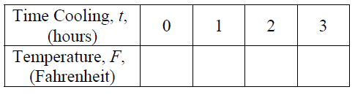
- Write a linear function that relates the Fahrenheit temperature, F(t), to the time in hours, t, that it has been falling.

- According to your function, what is the temperature when t =2.75 hours?

- If this cooling continues at this constant rate, how many hours will it take for the temperature to reach the freezing point of water? Show your work.

- a. Graph and fill the table of values for the following absolute value function:
$f\left(x\right)=\left|x+3\right|$. No need for a calculator.

- Is it possible to rewrite this function in two pieces??
$f\left(x\right)=\left\{\begin{aligned} \\ \end{aligned}\right.$

